Lab 2: I Robot



**2.1 Introduction**

In this lab we will study functions that describe motion. These functions are important in computer graphics, robotics, and other areas of engineering and computer science.

The first part of the lab will help us learn about position, velocity, and acceleration. Then we will learn about the functions used to describe motion and collisions, including a preview of some material coming later in ENGR 121 lectures. In the challenge section we will have a bit of fun with some simple “robots” (actually toy cars).

**2.2 Position, Velocity, Acceleration**

***Position*** describes where you are relative to an origin you pick. In a 1D world position is usually represented by the variable *x*. In 2D by *x* and *y*, and in 3D by *x*, *y*, *z*. But we will stick with 1D for now, with a bit of 2D in the challenge section.

The robot below is at *x* = 4 m.

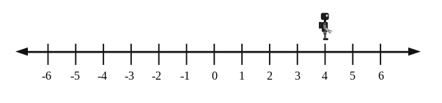

***Velocity*** describes which way you are going and how fast. For example, if the robot above is moving toward more positive positions (right in the diagram below) at 1 m/s then we say it has a velocity of +1 m/s. If it moves toward more negative numbers at 1 m/s (left in the diagram below) it has a velocity of -1 m/s.

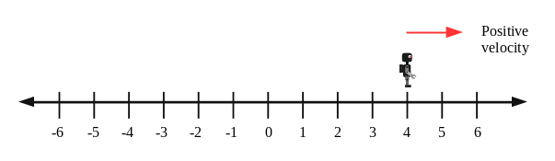

**CORE 1 (6 marks)**

Make a quick sketch of a number line similar to the ones above. Sketch a robot with position -3 m and velocity + 1 m/s (indicate velocity with an arrow as above).

*********************************************************

*********************************************************

Notice the sign of the velocity tells you which way you are travelling. With a number line pointed to the right, your velocity is positive if you are travelling to the right and negative if you are travelling to the left. The velocity does not depend on where you are, just which way you are going.

Notice also that if you have a non-zero velocity your position is changing.

***Velocity is the rate of change of position.***

***Acceleration***. The sign of the acceleration is commonly misunderstood. Essentially acceleration means changing velocity. The common misconception is that positive acceleration means speeding up and negative acceleration means slowing down and is sometimes called deceleration. This is a wrong concept. The sign of the acceleration is depends on which way you are being pushed. If you are being pushed toward the positive direction your acceleration is positive.

If the velocity is already positive and you get a push in the positive direction, you will speed up. If the velocity is negative a push in the positive direction will cause you to slow. What happens with a negative acceleration? Think about this a minute and then continue.

We can summarize succinctly as follows:

When the acceleration is in the same direction as the velocity you speed up. When the acceleration is opposite the velocity you slow down. If you have zero velocity then any acceleration will cause you to speed up.

**CORE 2 (4 marks)**

For each of the number lines below, determine whether the acceleration is positive or negative and whether the robot will speed up or slow down.

*********************************************************

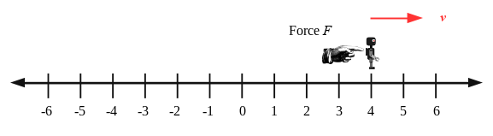

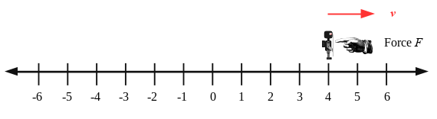

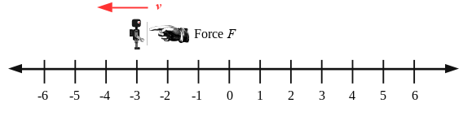

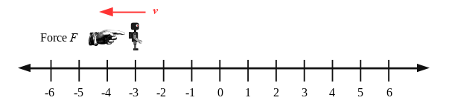

*********************************************************

**Some Fun: Walk the Graph**

This is a demonstration of sorts. A volunteer student will walk back and forth in front of a sonar and try to match position and velocity graphs. Students will yell out instructions. Take a few notes.

**CORE 3 (5 marks)**

Name two common types of SONAR and describe how they work based on your tutor’s presentation.

*********************************************************

*********************************************************

**Hmm ….**

Notice the position, velocity, and acceleration all change with time. So we are suddenly thinking about position, velocity, and acceleration as functions (outputs) of time rather than just variables. We have *x*(*t*), *v*(*t*), and *a*(*t*).

**2.2 Functions for Position, Velocity, and Acceleration**

The functions that describe motion in 3D can be quite complicated indeed! But we will stick with motion in 1D that has a constant acceleration. So *a*(*t*)=*a*, where *a* is a constant. Later in ENGR 121 you will learn how to derive these equations. Using equations to describe motion is a part of physics called ***kinematics***.

**CORE 4 (5 marks)**

Warm-up

Suppose east is the positive direction. You start at the origin and drive at +100 km/hr for two hours. Where will you end up?

*********************************************************

*********************************************************

Suppose you start at *x* = 200 km and drive at -50 km/hr for three hours. Where will you end up?

*********************************************************

*********************************************************

We can summarize what you just did in an equation. For constant velocity (in other words zero acceleration),

$x=x_{i}+vt$ ( Eq. 1, for zero acceleration = constant velocity)

**CORE 5 (5 marks)**

Check to make sure this equation gives the same results as your calculation in CORE 4.

*********************************************************

*********************************************************

For constant acceleration in general,

$v=v_{i}+at$ (Eq. 2, for constant acceleration)

$x=x_{i}+v_{i}t+\frac{1}{2}at^{2}$ (Eq 3, for constant acceleration)

**CORE 6 (5 marks)**

Equation 3 works if the acceleration is a constant. That means any constant. Suppose the acceleration is *a*=0 (which is a constant). Plug that into eq 3 and see what you get. Compare to equation 1 and explain the relationship between these equations.

*********************************************************

*********************************************************

**CORE 7 (5 marks)**

A robot starts with an initial velocity of -10 m/s and 4 seconds later is it travelling at -2 m/s. What was its average acceleration during that time?

*********************************************************

*********************************************************

**CORE 8 (10 marks)**

Practice problems

A robot has an initial position of *x* = +1000 m and travels at -5 m/s for 100 seconds. What is its final position?

*********************************************************

*********************************************************

A robot has an initial position of *x*i = -500 m and travels at +10 m/s. When will it reach 100 m?

*********************************************************

*********************************************************

A robot has initial position *x*i = 300 m and final position *x*f = 700 m 8 seconds later. What was its average velocity?

*********************************************************

*********************************************************

*********************************************************

**2.3 Chasing and Colliding**

Have you ever seen a collision in a computer game? Right - silly question. That’s most of what happens. Collisions (and avoiding them) are critically important in computer graphics, robotics, self-driving cars, automatic lawn mowers, and countless other applications.

Suppose we have two robots whose positions are given by *x*1(*t*) and *x*2(*t*). The statement that they collide is expressed mathematically as *x*1(*t*)= *x*2(*t*) at the some time which we might call *t*collision. (If they have the same position at the same time, then, well…)

**Example problem**

Robot 1 starts at an initial position of 100 m and travels with velocity +5 m/s. Robot 2 starts at *x* = 50 m and travels at +10 m/s. Will they collide? If so, when?

**Solution:**

First write equations for the positions of each. Here we have constant velocities so we use

$x=x_{i}+vt$

We have

 and 

The collision occurs when *x*1 = *x*2 or



Solving for *t* gives *t* = 10 seconds. That’s when they collide. But let’s check our work. At time *t*=10 seconds we have





Yes, the positions are indeed the same at *t*=10 seconds.

**COMPLETION 1 (10 marks)**

Robot 1 starts at *x* = 100 m and travels at +20 m/s. Robot 2 starts at *x* = 250 m and travels at -10 m/s. When do they collide? Check your work.

*********************************************************

*********************************************************

**COMPLETION 2 (5 marks)**

What do you suppose it means if there is no solution to the *x*1 = *x*2 equation?

*********************************************************

*********************************************************

**2.4 Fancier Functions**

Have a look at the graph below which gives the position of a robot against time. From 5 to 10 seconds the position is changing more per second than from 0 to 5 seconds, so we expect the velocity is higher. We can find the velocity of the robot in each of these time intervals using equation 1 or by finding the gradient (slope) of the graph.

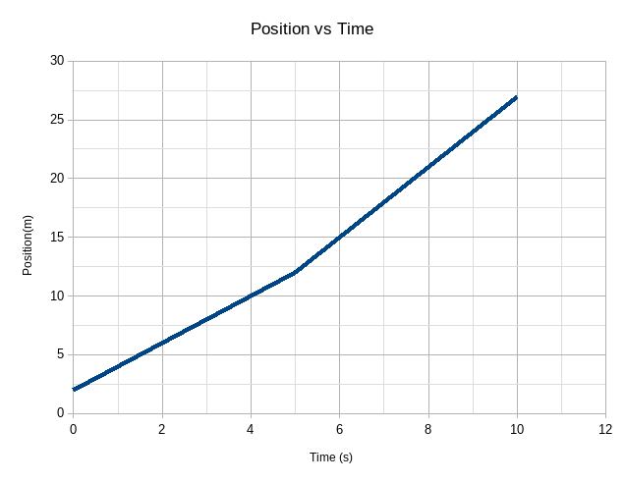

**COMPLETION 3 (10 marks)**

Find the velocities in each of the two time segments by finding the gradient. Discuss how this is related to equation 1: show that using equation 1 and finding the gradient are the same.

*********************************************************

*********************************************************

Consider the graph of velocity versus time below.

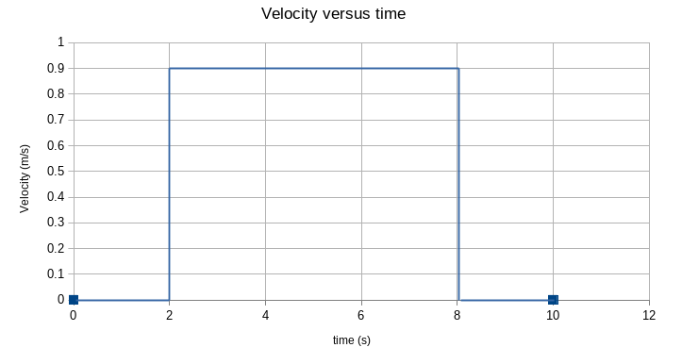

**COMPLETION 4 (10 marks)**

First of all, this is not even a function. Explain why it is not a function and fix the problem(s). Hint: What is the velocity at exactly *t*=2 sec?

*********************************************************

*********************************************************

**COMPLETION 5 (5 marks)**

Your velocity graph is hopefully now a function but it is unphysical. It could not represent real motion and would make computer graphics look obviously fake if used there. Explain why. Hint: describe the motion.

*********************************************************

*********************************************************

**COMPLETION 6 (5 marks)**

This is a preview of material you will study later in the term. We will see then that the area under the velocity curve gives the displacement of an object. Find the displacement of the robot (how far the robot has moved) from time *t* = 0 to *t* = 10 seconds.

*********************************************************

*********************************************************

**CHALLENGE PROJECT For Week 2 (up to 10 marks)**

In this challenge project we will attempt to aim one robot at another as in the diagram below:

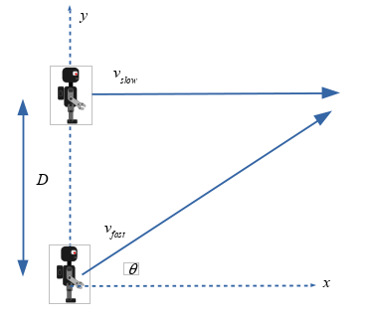

The lower robot travels at constant speed *v*fast and the upper robot travels at constant speed *v*slow. So both have zero acceleration. The initial vertical distance between them is *D*. Your challenge is to find the angle $θ$ needed to cause a collision.

Some notes that may help:

1. We can treat motion along the horizontal and vertical in the picture separately and write separate equations for them. Let’s call horizontal *x* and vertical *y*.
2. We then need to find kinematic equations for *x* and *y* for each robot. In other words you need equations for *x*slow*, y*slow*, x*fast*, y*fast.
3. The fast robot has velocity in the *x* and *y* directions. The *x*-component of the robot’s velocity is while the *y* component is . The initial position of the fast robot is (0,0). So we can write the kinematic equations (eq 1) as

 and 

1. The slow robot has velocity only in the *x* direction. In the *y* direction the velocity is zero. The initial position of the slow robot is (0,*D*).

Your tutor will help you measure the speeds of the robots and give you a value for *D*. You have all the pieces you need to find the angle that will cause a collision. Good luck! We will test your solution - will you get a collision?